20 September 2024 postcard

Off to Lake Como! (But George wasn't there.)

This morning we had to have our luggage ready (just inside our rooms) at 7 am. Breakfast started at 7 am also, and we then met in the lobby at 8 am for an 8:15 am departure by gigantic luxury bus to Lake Como. Seating was assigned (and rotated daily so that everybody got to sit in the "best" spots), but there was so much space left over that anyone who wanted could have a row of seats to themselves.

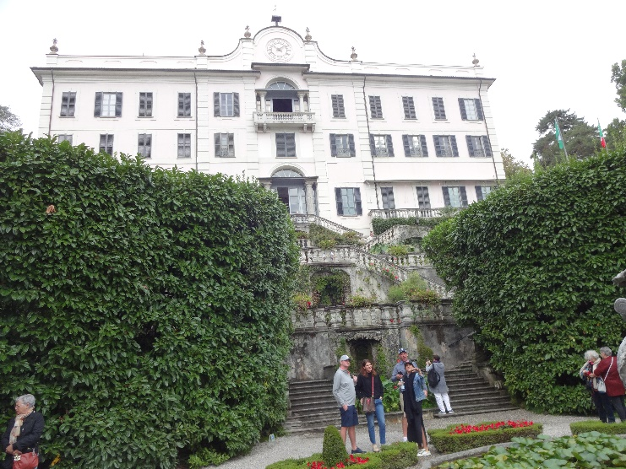Lake Como is shaped like an inverted capital Y. We passed through the town of Como, at the southern tip of the western arm, but continued up the shoreline to Tremezzo, where we stopped for a self-guided tour of the Villa Carlotta, a large house with extensive gardens. The lake is so deep (second deepest in Europe outside Norway), and therefore contains such a mass of water, that it has a moderating effect on the climate, so the gardens feature figs, citrus, palm trees, etc.

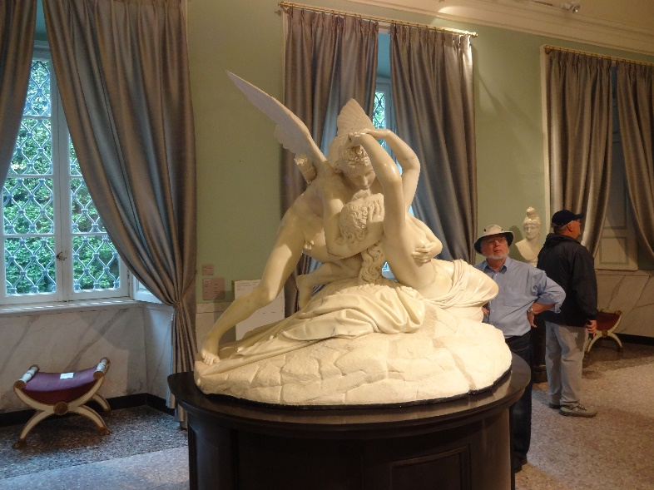The villa contains a collection of reproductions of sculpture and miniature paintings by artists the owners liked (here, Cupid and Psyche by Canova). It's called Carlotta because it was a wedding gift from the owner to his daughter, Carlotta.

From there, we had a 5-minute private boat ride across the lake to Bellagio, the town at the tip of the promontory between the two arms of the lake. (The rock of the promontory is so hard that it split the glacier that was gouging out the lake bed, causing it to gouge out two diverging arms rather than continuing straight south. ("Bellagio" comes from the Latin for "two lakes.")

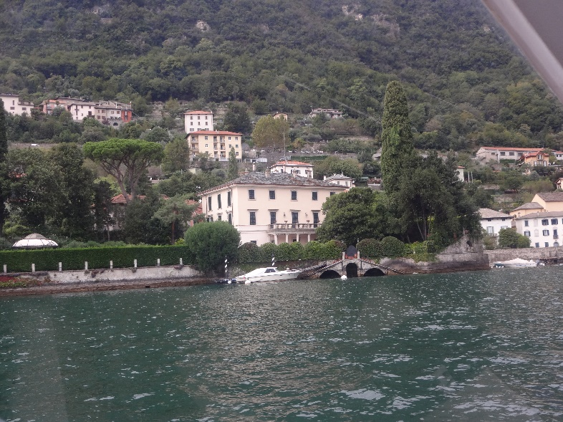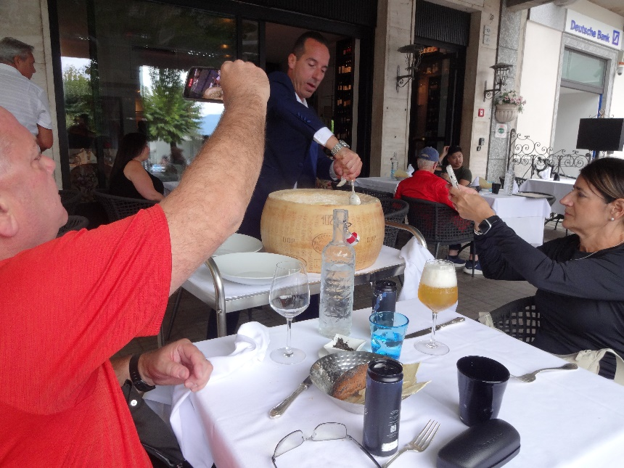We were on our own for lunch there, but several of us accepted the guide's suggestion to eat at the restaurant of the Hotel Suisse, so he called ahead and made us a reservation. We had already ordered before we saw it for the first time, but the most spectacular dish they made (which was ordered by at least half the people there) was actually made in a large wheel of Parmesan cheese. The top surface had been sliced off and a hollow carved in the cheese. For each pair of servings, the waiter wheeled the cheese to the table, dumped in a steaming bowl of fettucine and hot cream, and proceeded to stir and toss it vigorously, scraping semimelted Parmesan from the sides into the mix as he went. After he divided the resulting mix between two plates, he offered optional black pepper and shaved truffles. Here he is preparing it for the table next to ours.

After some shopping time (Bellagio is known for silk and items carved from olive wood), we reboarded our boat for an hour's tour of some of the most spectacular villas along the shores. One of them (not actually the most spectacular) is George Clooney's, and his boat was tied up at the dock, but its cover was on, and all the windows were shuttered, so he probably wasn't there.

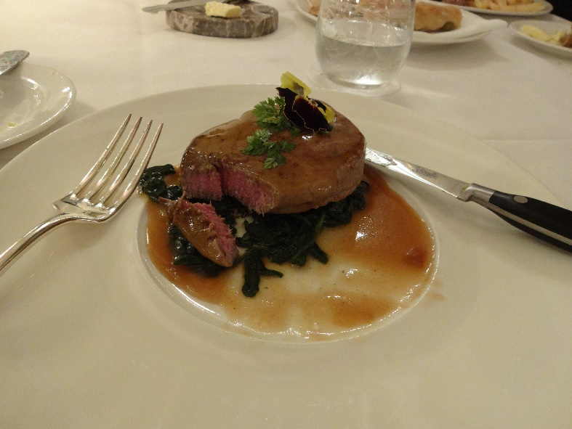

Then it was back to the bus for the ride to our hotel in Stresa, on Lake Maggiore, the Grand Hotel des Îles Boromées, which is over-the-top baroque in decor.

Here's my dinner main course: beef tournedos stuffed with foie gras on a bed of braised spinach, medium rare as ordered.